**SPRING BOOT**

Links –

1. <https://spring.io/projects/spring-boot>

**THE PROBLEM**

* What Maven archetype to use?
* Which Maven dependencies do I need?
* How do I set up configuration (xml or Java)?
* How do I install the server?

And that’s just the basics for getting started.

* Tons of configuration.

**THE SOLUTION**

* Make it easier to get started with Spring development
* Minimize the amount of manual configuration
  + Perform auto-configuration based on props files and JAR classpath
* Help to resolve dependency conflicts (Maven or Gradle)
* Provide an embedded HTTP server so to get started quickly
  + Tomcat, Jetty, Undertow.

**Spring Initializer –** [**http://start.spring.io**](http://start.spring.io)

* Quickly create a started Spring project
* Select your dependencies
* Creates a Maven/Gradle project
* Import the project into the IDE

**Spring Boot Embedded Server**

* Provide an embedded HTTP server to get started quickly
  + Tomcat, Jetty, Undertow
* No need to install a server separately.

**BASICALLY, A SELF-CONTAINED UNIT, NOTHING TO INSTALL**

**Running Spring Boot Apps**

* Spring Boot Apps can be run standalone (includes embedded server)
* Run the Spring Boot app from the IDE or Command Line
  + java -jar filename.jar

**Deploying Spring Boot Apps**

* Spring Boot Apps can be deployed in the traditional way.
* Deploy the WAR file to an external server: Tomcat, JBoss, WebSphere etc.

**FAQ**

1. **Does Spring Boot replace Spring MVC, Spring REST etc?**

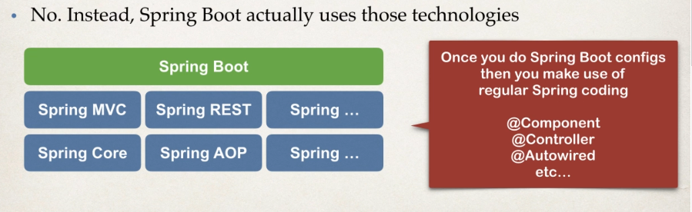

1. **Does Spring Boot run code faster than regular Spring code?**

No. Behind the scenes, Spring Boot uses the same code of Spring framework. Spring boot is about making it easier to get started. Minimizing configuration.

1. **Any special IDE for Spring Boot?**

No.

**Spring Initializer**

* **Quickly create a starter Spring project**
* **Select the dependencies**
* **Creates a Maven/Gradle project**
* **Import the project into the IDE.**

**Development Process**

1. **Configure the project at Spring Initializer Website**
2. **Download the zip file**
3. **Unzip it**
4. **Import the Maven project into the IDE.**

**Create a simple REST controller.**



**But to run it, we need the application file and run it as “Run on server” since server is already embedded.**

**Spring Boot Project Structure**

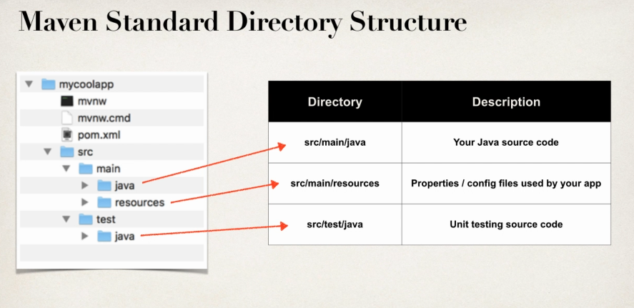

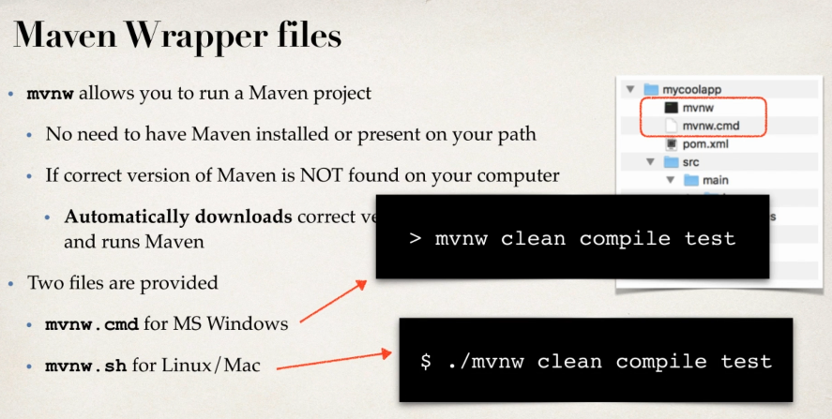

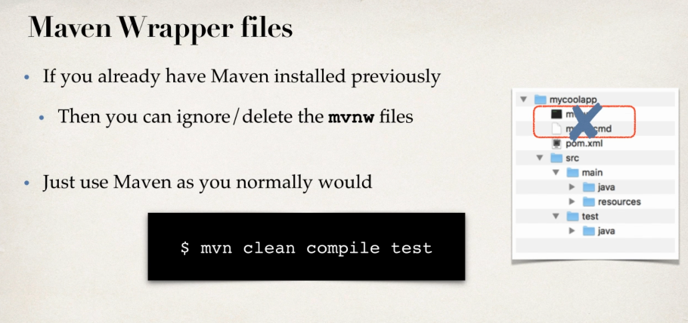

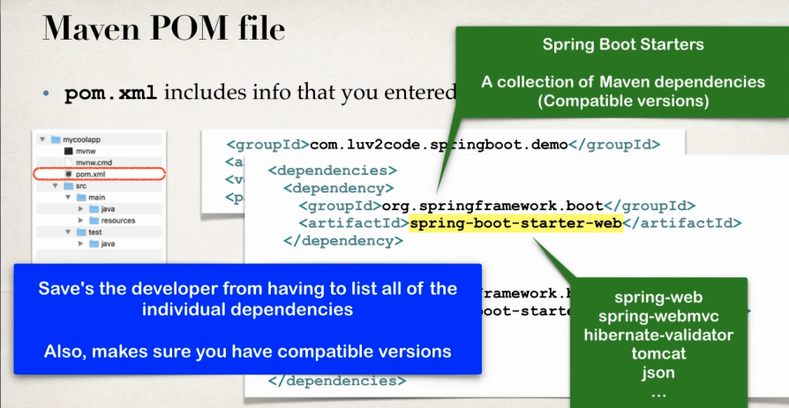

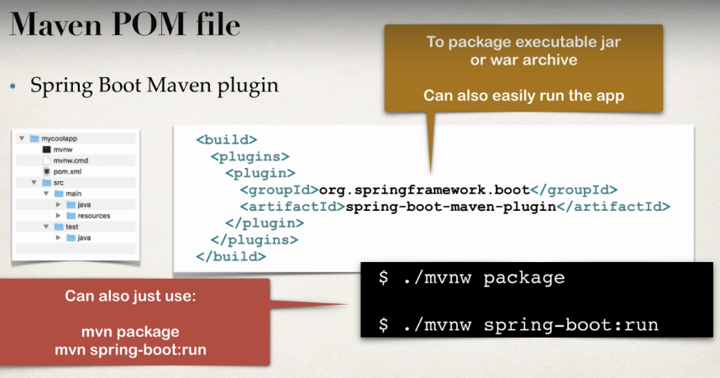

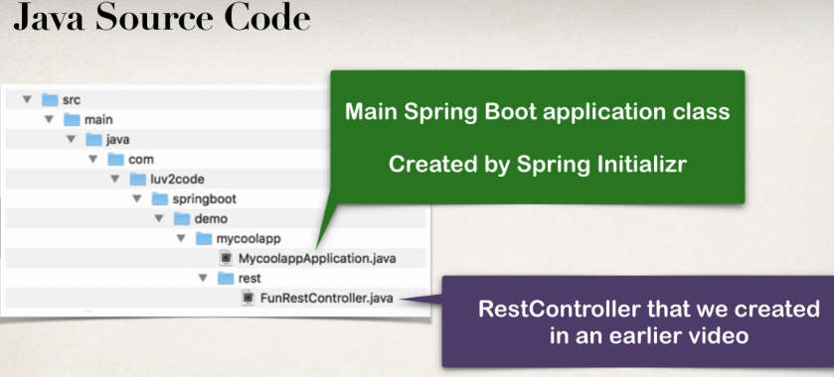

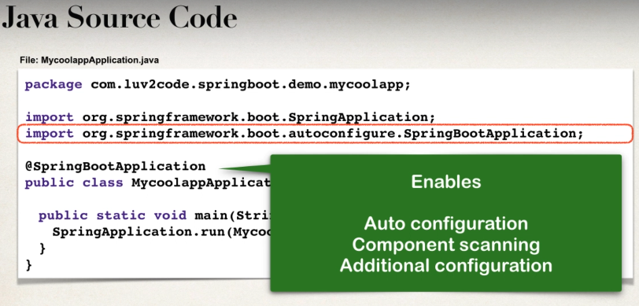

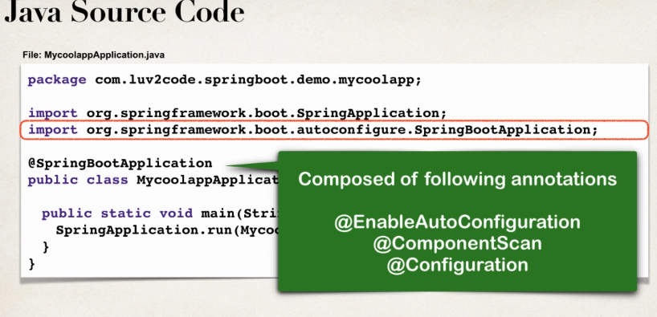

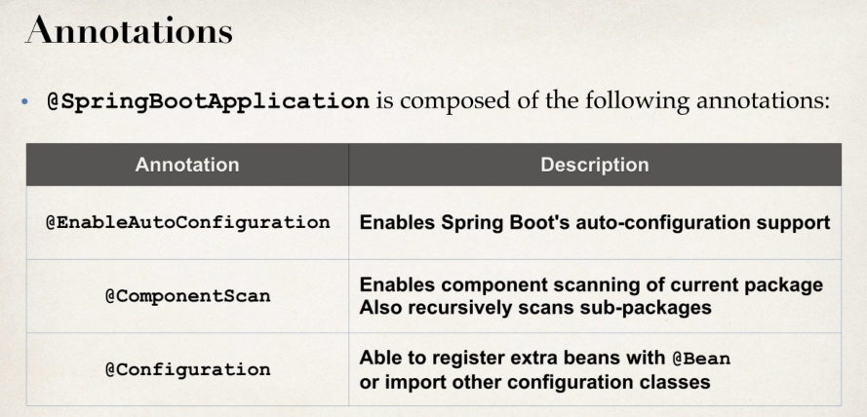

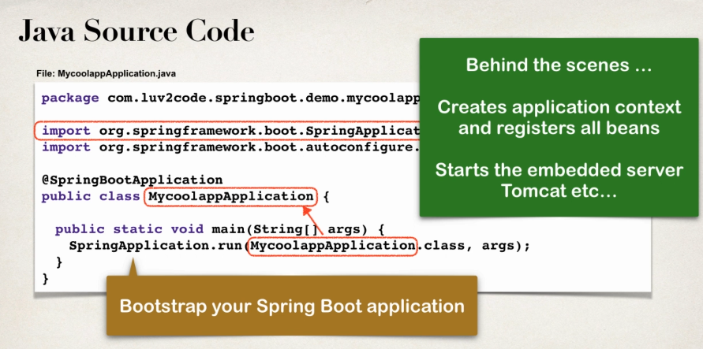

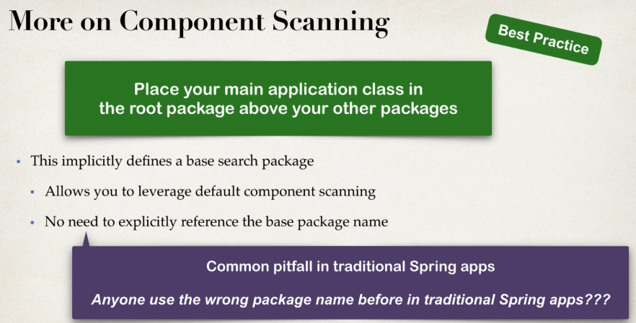

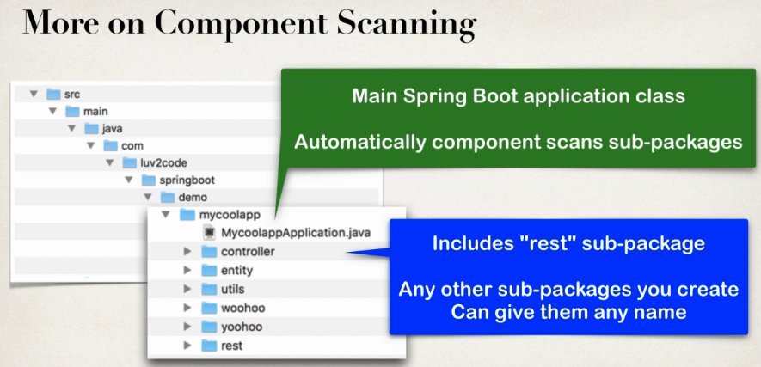

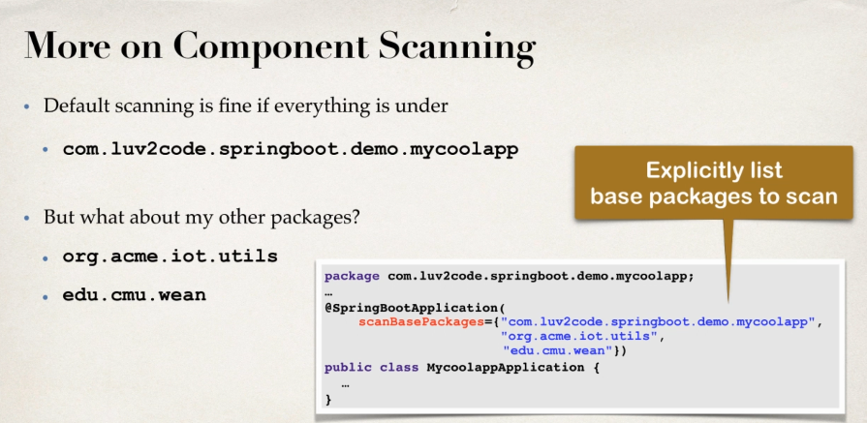

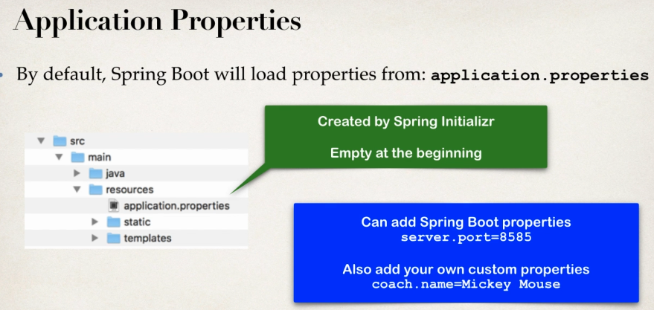

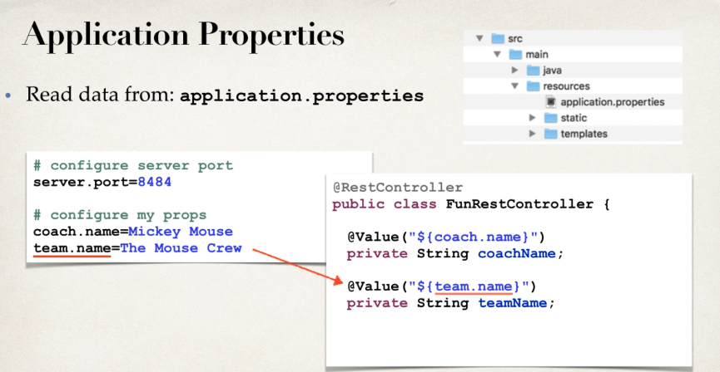

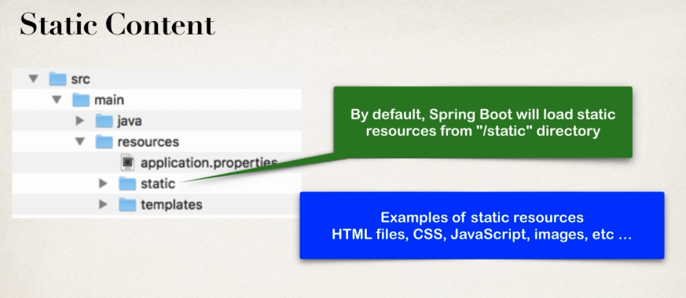

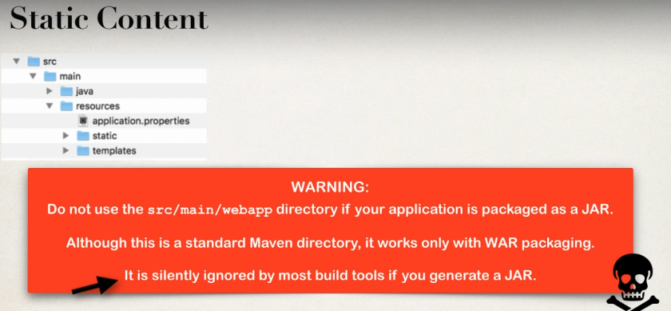

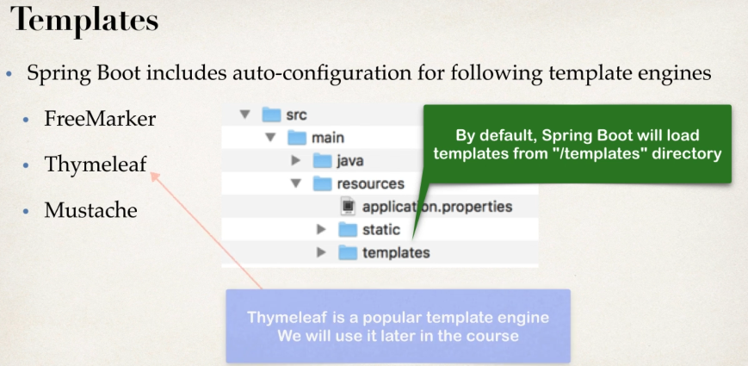

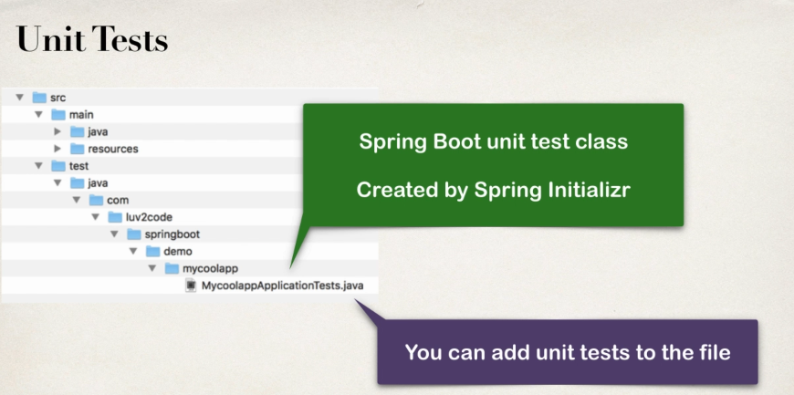

**Spring Boot Starters**

* **A curated list of Maven dependencies**
* **A collection of dependencies grouped together**
* **Tested and verified by Spring development team**
* **Makes it much easier for the developer to get started with Spring**
* **Reduces the amount of Maven configuration**

While making a spring mvc application, we need to add various dependencies such as ***Spring-webmvc***, ***hibernate*** one by one at a time. However, if we use Spring boot Starters and use the Spring initializer and select ***spring boot starter web***, we will get all of the dependencies such as ***Spring web, spring-webmvc, hibernate-validator, json, tomcat*** all of those at once. It saves the develop from having to list all of the individual dependencies and also makes sure that we have compatible versions.

There are 30+ Spring boot starters from the Spring Development Team.

|  |  |
| --- | --- |
| Name | Description |
| spring-boot-starter | Core starter, including auto-configuration support, logging and YAML |
| spring-boot-starter-activemq | Starter for JMS messaging using Apache ActiveMQ |
| spring-boot-starter-amqp | Starter for using Spring AMQP and Rabbit MQ |
| spring-boot-starter-aop | Starter for aspect-oriented programming with Spring AOP and AspectJ |
| spring-boot-starter-artemis | Starter for JMS messaging using Apache Artemis |
| spring-boot-starter-batch | Starter for using Spring Batch |
| spring-boot-starter-cache | Starter for using Spring Framework’s caching support |
| spring-boot-starter-data-cassandra | Starter for using Cassandra distributed database and Spring Data Cassandra |
| spring-boot-starter-data-cassandra-reactive | Starter for using Cassandra distributed database and Spring Data Cassandra Reactive |
| spring-boot-starter-data-couchbase | Starter for using Couchbase document-oriented database and Spring Data Couchbase |
| spring-boot-starter-data-couchbase-reactive | Starter for using Couchbase document-oriented database and Spring Data Couchbase Reactive |
| spring-boot-starter-data-elasticsearch | Starter for using Elasticsearch search and analytics engine and Spring Data Elasticsearch |
| spring-boot-starter-data-jdbc | Starter for using Spring Data JDBC |
| spring-boot-starter-data-jpa | Starter for using Spring Data JPA with Hibernate |
| spring-boot-starter-data-ldap | Starter for using Spring Data LDAP |
| spring-boot-starter-data-mongodb | Starter for using MongoDB document-oriented database and Spring Data MongoDB |
| spring-boot-starter-data-mongodb-reactive | Starter for using MongoDB document-oriented database and Spring Data MongoDB Reactive |
| spring-boot-starter-data-neo4j | Starter for using Neo4j graph database and Spring Data Neo4j |
| spring-boot-starter-data-r2dbc | Starter for using Spring Data R2DBC |
| spring-boot-starter-data-redis | Starter for using Redis key-value data store with Spring Data Redis and the Lettuce client |
| spring-boot-starter-data-redis-reactive | Starter for using Redis key-value data store with Spring Data Redis reactive and the Lettuce client |
| spring-boot-starter-data-rest | Starter for exposing Spring Data repositories over REST using Spring Data REST |
| spring-boot-starter-data-solr | Starter for using the Apache Solr search platform with Spring Data Solr |
| spring-boot-starter-freemarker | Starter for building MVC web applications using FreeMarker views |
| spring-boot-starter-groovy-templates | Starter for building MVC web applications using Groovy Templates views |
| spring-boot-starter-hateoas | Starter for building hypermedia-based RESTful web application with Spring MVC and Spring HATEOAS |
| spring-boot-starter-integration | Starter for using Spring Integration |
| spring-boot-starter-jdbc | Starter for using JDBC with the HikariCP connection pool |
| spring-boot-starter-jersey | Starter for building RESTful web applications using JAX-RS and Jersey. An alternative to [spring-boot-starter-web](https://docs.spring.io/spring-boot/docs/current/reference/htmlsingle/#spring-boot-starter-web) |
| spring-boot-starter-jooq | Starter for using jOOQ to access SQL databases. An alternative to [spring-boot-starter-data-jpa](https://docs.spring.io/spring-boot/docs/current/reference/htmlsingle/#spring-boot-starter-data-jpa) or [spring-boot-starter-jdbc](https://docs.spring.io/spring-boot/docs/current/reference/htmlsingle/#spring-boot-starter-jdbc) |
| spring-boot-starter-json | Starter for reading and writing json |
| spring-boot-starter-jta-atomikos | Starter for JTA transactions using Atomikos |
| spring-boot-starter-jta-bitronix | Starter for JTA transactions using Bitronix. Deprecated since 2.3.0 |
| spring-boot-starter-mail | Starter for using Java Mail and Spring Framework’s email sending support |
| spring-boot-starter-mustache | Starter for building web applications using Mustache views |
| spring-boot-starter-oauth2-client | Starter for using Spring Security’s OAuth2/OpenID Connect client features |
| spring-boot-starter-oauth2-resource-server | Starter for using Spring Security’s OAuth2 resource server features |
| spring-boot-starter-quartz | Starter for using the Quartz scheduler |
| spring-boot-starter-rsocket | Starter for building RSocket clients and servers |
| spring-boot-starter-security | Starter for using Spring Security |
| spring-boot-starter-test | Starter for testing Spring Boot applications with libraries including JUnit, Hamcrest and Mockito |
| spring-boot-starter-thymeleaf | Starter for building MVC web applications using Thymeleaf views |
| spring-boot-starter-validation | Starter for using Java Bean Validation with Hibernate Validator |
| spring-boot-starter-web | Starter for building web, including RESTful, applications using Spring MVC. Uses Tomcat as the default embedded container |
| spring-boot-starter-web-services | Starter for using Spring Web Services |
| spring-boot-starter-webflux | Starter for building WebFlux applications using Spring Framework’s Reactive Web support |
| spring-boot-starter-websocket | Starter for building WebSocket applications using Spring Framework’s WebSocket support |

**What is in the Starter?**

Open pom.xml and select tab ***Dependency Management/View Feature.***

**Spring Boot Starter Parent**

* Spring Boot provides a “Starter Parent”
* Special Starter that provides Maven defaults.
* Already included in *pom.xml* when using Spring Initializer.
* Maven defaults defined in the Starter Parent.
  + Default compiler level (*current Java 8)*
  + UTF-8 source encoding
* To override a default, set as a property

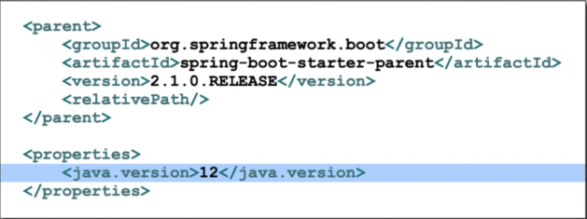

* Default configuration of Spring Boot plugin

**Benefits of the Spring Boot Started Parent**

* Default Maven configuration: Java version, UTF-encoding etc.
* Dependency Management
  + Use version on Parent only.
  + Spring-boot-starter-* dependencies inherit version from parent.
* Default configuration of Spring Boot plugin

**Spring Boot Dev Tools**

**The problem**

* When running Spring Boot applications, if we make any change to source code, then we have to manually restart the application.

The Solution

* Spring-boot-devtools
* Automatically restarts the application when code is updated
* Simply add the dependency to the POM file
* No need to write the additional code.

Edit pom.xml and add the below dependency. Add new RESR endpoint to the app. Verify the app is automatically reloaded.



Link - <https://docs.spring.io/spring-boot/docs/current/reference/htmlsingle/#using-boot-devtools>

**Spring Boot Actuators**

Problem

* How to monitor and manage the application?
* How to check the application health?
* How to access application metrics?

Solution

* Exposes endpoints to monitor and manage the application
* Easily get DevOps functionality out-of-the-box.
* Simply add the dependency to the POM file.
* REST endpoints are automatically added to the application.

**Add the dependency**



* Automatically exposes the endpoint for metrics.
* Endpoints are prefixed with: /actuator

Health Endpoint

* ***/health*** checks the status of application
* Normally used by monitoring apps to see if app is up or down.

Info Endpoint

* ***/info*** gives information about the application
* Default is empty
* So, update the properties file.

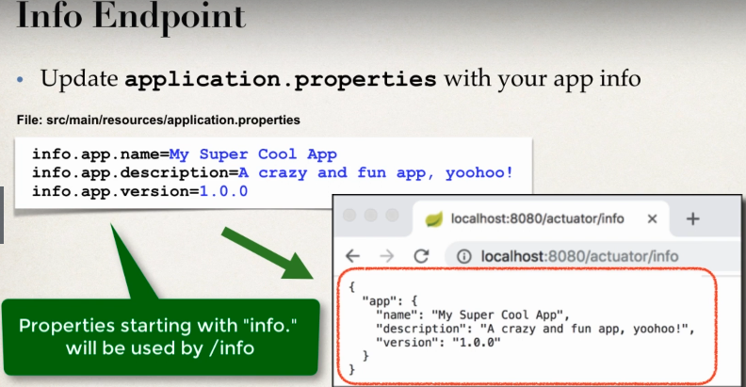

**Endpoints are available:**

|  |  |
| --- | --- |
| ID | Description |
| auditevents | Exposes audit events information for the current application. Requires an AuditEventRepository bean. |
| beans | Displays a complete list of all the Spring beans in your application. |
| caches | Exposes available caches. |
| conditions | Shows the conditions that were evaluated on configuration and auto-configuration classes and the reasons why they did or did not match. |
| configprops | Displays a collated list of all @ConfigurationProperties. |
| env | Exposes properties from Spring’s ConfigurableEnvironment. |
| flyway | Shows any Flyway database migrations that have been applied. Requires one or more Flyway beans. |
| health | Shows application health information. |
| httptrace | Displays HTTP trace information (by default, the last 100 HTTP request-response exchanges). Requires an HttpTraceRepository bean. |
| info | Displays arbitrary application info. |
| integrationgraph | Shows the Spring Integration graph. Requires a dependency on spring-integration-core. |
| loggers | Shows and modifies the configuration of loggers in the application. |
| liquibase | Shows any Liquibase database migrations that have been applied. Requires one or more Liquibase beans. |
| metrics | Shows ‘metrics’ information for the current application. |
| mappings | Displays a collated list of all @RequestMapping paths. |
| scheduledtasks | Displays the scheduled tasks in your application. |
| sessions | Allows retrieval and deletion of user sessions from a Spring Session-backed session store. Requires a Servlet-based web application using Spring Session. |
| shutdown | Lets the application be gracefully shutdown. Disabled by default. |
| threaddump | Performs a thread dump. |

If your application is a web application (Spring MVC, Spring WebFlux, or Jersey), you can use the following additional endpoints:

|  |  |
| --- | --- |
| ID | Description |
| heapdump | Returns an hprof heap dump file. |
| jolokia | Exposes JMX beans over HTTP (when Jolokia is on the classpath, not available for WebFlux). Requires a dependency on jolokia-core. |
| logfile | Returns the contents of the logfile (if logging.file.name or logging.file.path properties have been set). Supports the use of the HTTP Range header to retrieve part of the log file’s content. |
| prometheus | Exposes metrics in a format that can be scraped by a Prometheus server. Requires a dependency on micrometer-registry-prometheus. |

Link - <https://docs.spring.io/spring-boot/docs/current/reference/htmlsingle/#production-ready-endpoints>

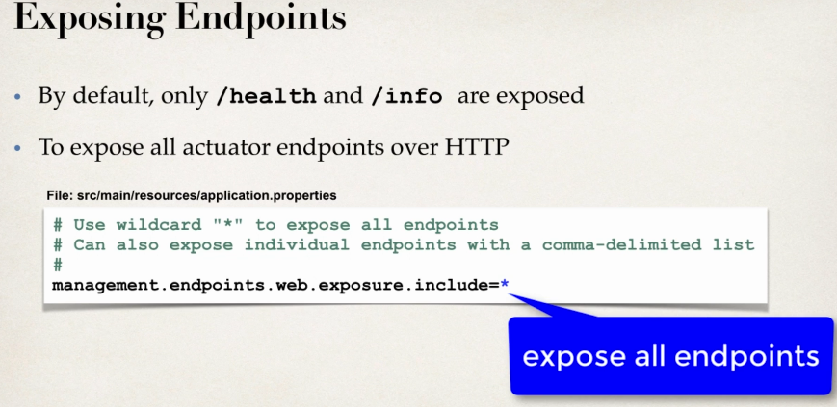

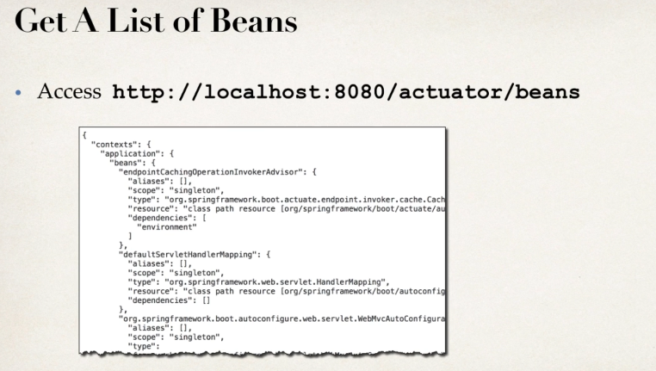

Development Process

1. Edit the pom.xml and add ***spring-boot-starter-actuator***
2. View actuator endpoints for: ***/health and /info***
3. Edit ***application.properties*** to customize ***/info***
4. Adding Dependency



1. View endpoints
   1. localhost:8080/actuator/health
   2. localhost:8080/actuator/info [Default will be empty until and unless application.properties is being added with details]
2. Editing application.properties to customize /info



**SECURITY**

* User may NOT want to all of the information.
* Add Spring Security to project and endpoints are secured.

**Secured Endpoints**

* When user is accessing: ***/actuator/beans***, Spring Security will prompt for login. Look at the console to look at the actual password.
* Overriding default user name and generated password is also allowed in the ***application.properties*** file.

spring.security.user.name=**sayantan**

spring.security.user.password=**password**

* **Excluding Endpoints in application.properties**
  + management.endpoints.web.exposure.exclude=health,info

**Links –**

1. [**https://www.javatpoint.com/spring-boot-actuator**](https://www.javatpoint.com/spring-boot-actuator)
2. [**https://docs.spring.io/spring-boot/docs/current/reference/htmlsingle/#production-ready**](https://docs.spring.io/spring-boot/docs/current/reference/htmlsingle/#production-ready)

**Spring Boot – Run from Command Line**

* No need to have IDE open/running
* Since we are using Spring boot, server is already embedded in our JAR file
  + No need to have separate server installed/running
* Spring Boot apps are self-contained.

**Two options for running the app**

1. User **java -jar**
   1. GO to the respective work directory in CMD
      1. RUN ***“mvnw package”***
      2. Move to target folder (newly created)
      3. Java -jar “FileName”.jar
2. User Spring Boot Maven plugin
   1. mvnw spring-boot: run
      1. Run it in the work directory in CMD.